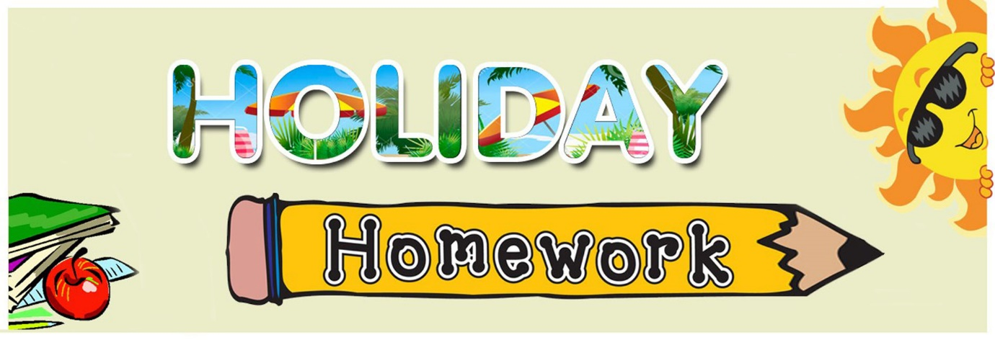

Holiday Homework (2022-23)
Class 5
English
* Prepare a dictionary having minimum five words of each alphabet (new words) with meaning to enhance the vocabulary. Cover it with beautiful Cover.
* Make a separate notebook and do 20 pages of cursive writing in it.
* Prepare a video on any poem ( English) in school uniform (1.5-2 minutes)
* Make your own video in proper school uniform ( speech on balanced diet ( healthy food)/junk food by showing proper things).
* Make a beautiful card on Father's Day.
* Learn Unit Test-1 syllabus
Unit-1,2,3 (full)
Grammar-
1.Punctuation
2.Three Forms of Verbs
3. Noun
4. Prepositions
Hindi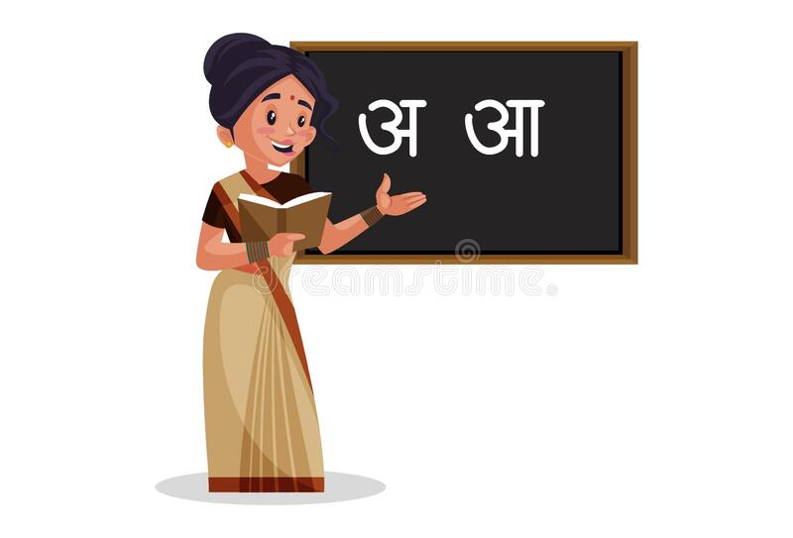
ग्रीष्म अवकाश गृह कार्य
* पाठ 1,2 याद करें
*समाचार पत्र पढ़ कर 20 नए शब्दों से वाक्य बनाइए।
* 'फसलों से संबंधित त्योहारों के चित्र A4 शीट पर चिपकाएँ और नाम लिखें।
* विभिन्न लिपियों के चिन्हों को दर्शाते हुए A4 शीट पर लिखें।
* शिक्षाप्रद कहानियाँ पढ़ें।
* प्रतिदिन एक पेज सुलेख लिखें।
Maths

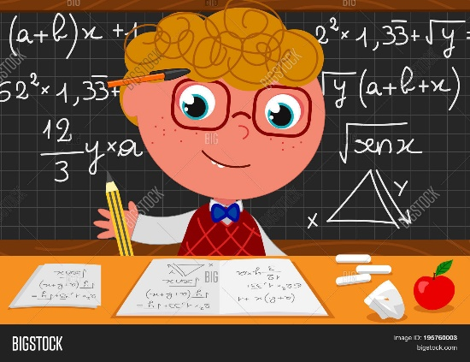
1.Do activity given on page 32 (angles in a paper aeroplane)
2. Make different shapes of polygon with the help of matchsticks on A4 sheet (page 19 )
3. Do Aptitude book from page 5 to 20
4. Learn tables from 2 to 20.
5 Solve the riddles:
a) I am a two digit number. The sum of my digits is 6.
I fall between 6 x 8 and 11x 5
Who am I?
b) I am less than a metre.
I am a multiple of 9.
The digits at my once and tens place are same.
Who am I ?

Revise full syllabus done in class and do your holidays homework on coloured A4 sheet.
S Sc

▪️Learn and Practice Lesson 1, 2, 3 and 4 ( In separate Notebook).
▪️Paste pictures of Current Prime Minister,Vice President. Chief Minister of Haryara, Punjab & Delhi and Chief Justice of India on half Chart.
▪️ Make a collage of different types of natural disasters.
▪️Draw the following diagrams according to your roll number on A4 sheet :
R. No. 1 to 10
Water cycle
R. No 11 to 20
The structure of the earth
R. No. 21-30
Biosphere
R. No. 31 to 40
Types of pollution
▪️Enact as a news reporter to present your report by predicting the climate of your area (prepare videos)
EVS
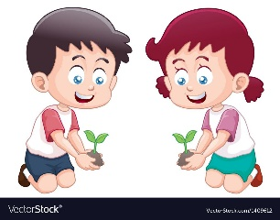
1. Make a video of a spoiled bread / chapati having fungus on it.
2. Make a video of germination of seeds.
3. Make your vaccination chart.
4. Visit any museum or monument, paste their pictures and write about them.
5. Write Kalpana Chawla and Sunita William’s experiences of living in space. Also paste their pictures.
Note- Do all the activities on A4 size sheet.
6. Learn and do written practice of L-1 to 3 and do reading practice.
Sanskrit
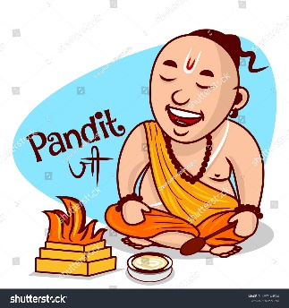
1. निम्न व्यंजनों से बनने वाले शब्द लिखें- (5-5) जैसे उ- उद्यानम्, उलूक: (A4 size)
1. क 2. ग 3. म 4. त 5.ल
2. भगवद् गीता के कोई दो श्लोक चार्ट पर अर्थ सहित लिखें । ( A 3 size)
3. बगीचे में पाई जाने वाली वस्तुओं के चित्र बनाकर उनके संस्कृत नाम लिखें। (A4 size)
4. पाठ 1, 2 याद करें।
Computer
1. Draw diagram of Abacus in computer notebook.
2. Draw or paste pictures of different types of microcomputers.
(Page no. 12-13)
3. Make presentation on generation of computer in MS PowerPoint.
4. Revise lesson 1, 2. Read L-3.

Gk 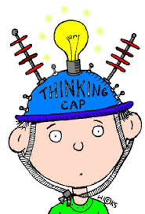
Unit test 1 syllabus exercise 1 - 20
Make a beautiful chart on A3 size sheet according to your roll numbers given below :
Roll no 1-5 Diwali/ Dussehra
Roll no 6- 10 Christmas/ Guru Purab
Roll no 11-15 Independence Day / Teej
Roll no 16-20 Haryana day/ Raksha Bandhan
Roll no 21-25 save water/ Teacher's Day
Roll no 26-30 good habits/ good manners
Roll no 31-35 slogan on cleanliness/ Shivratri
Roll no 36-40 Gandhi Jayanti / write national Anthem

Art
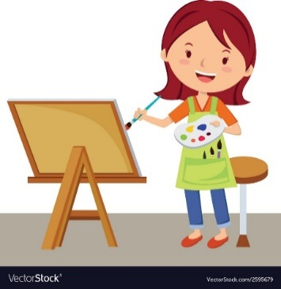

NOTE.
1.Use 1/4 Ivory chart for each topic.
2.Border strips is compulsory for all.
3.choose any four topics.
TOPICS
1) INDEPENDENCE CARD
2)DUSSHARA
3)JANMASHTAMI
4)TEEJ
5)DIWALI
CRAFT
Best out of waste

